Sketchbook Covers like Keith Haring!

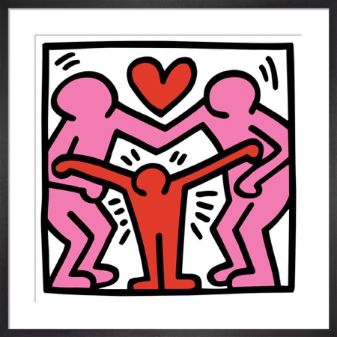
For this assignment you will design and create a full cover for your sketchbook in the style of Keith Haring. Remember, his style includes:
- Bright bold colours
- Black outlines and words
- Black line patterns
- Simplified characters
- Lines that suggest motion

Your cover must have the following:
- Your name
- An image of you (photo or drawn)
- At least 4 things you like, exploding out of your head
- A thought bubble with an idea/thought of yours
- Any patterns or motions
- Bright colours, including the background – don’t leave it brown!

Approaching Expectations  (C-Range) | Meeting Expectations  (B-Range) | Exceeding Expectations  (A-Range)
Design:
- You have included the 6 required components

Creating:
- Paint is applied carefully.
- We can read your words
- Black outlines are smooth and complete
- Patterns are even

Finishing:
- You followed clean up instructions.
- You arranged the elements of your composition so that your covers are interesting and look complete

