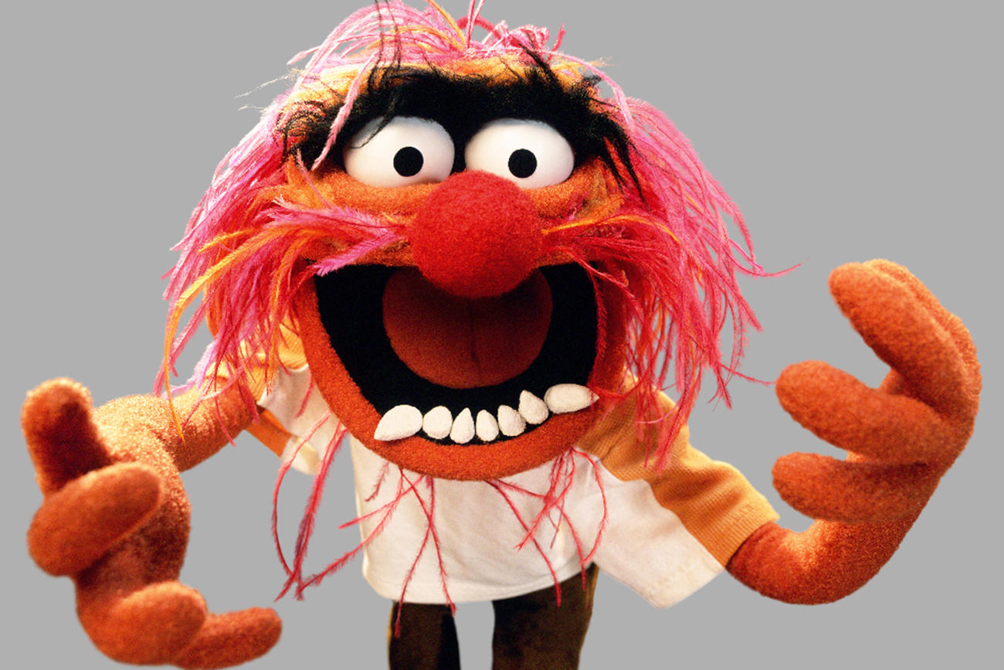
Puppets!

For this project you will design and make a muppet-styled puppet.

Steps in the project:

- Design: Which puppet will you make? (You may NOT recreate a puppet that already exists!) Draw images of the puppet design. We will all be working with the same head shape since this is your first puppet.
- Cut out the pieces. Build the puppet according to instructions.
- Style the puppet, including hair, eyes, and clothing.
- Create a persona for your puppet. How does it speak? Move? Does it have any tics?

Puppet Evaluation:

- (C-range) | Meets Expectations (B-range) | + (A-range)
- You have created drawings and notes in your sketchbook.
- Your plan is detailed.
- You list all the required materials.

- Puppet is constructed according to the instructions.
- It is assembled carefully and functions well as a puppet.
- Glue and stitching is not obvious.

- The puppet has an obvious, unique personality.
- It has a name and is introduced to the class.

Core Competencies:
- You have shown responsibility for tools, supplies, and the studio in general.
- You demonstrate a good attitude and work ethic.

