PHOTOGRAPHY GUESSING GAME

For this assignment you and a partner will go on a nature-walk and take pairs of photographs of the same SUBJECT(this is the thing that you are taking a picture of).

As you walk, try to recognize beautiful or interesting things (or SUBJECTS) to take pictures of.

Take one CLOSE-UP shot.
ZOOOOM in for this one – it’s a detail shot. The whole object doesn’t even have to be in the FRAME (what you can see in the viewing screen of your camera). See how close you can get with the photograph still being IN-FOCUS (not blurry). Try to make people confused about what they are looking at! Imagine that you want to make a guessing game with this photograph!

This is called in-camera CROPPING. (isolating or focusing-in on part of a larger picture)

Now move back and take a MEDIUM-SHOT. This means that you show the subject IN-CONTEXT (This means that you show the entire object and most of the stuff around it). This photograph should not confuse the viewer at all. It should be plain to recognize what we are looking at.

Ex: 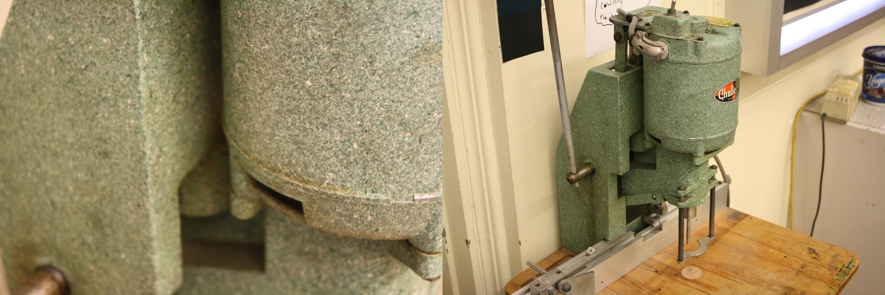

Try taking the pictures in the opposite order. Take the MEDIUM-SHOT first the get really CLOSE-UP.

Try taking pictures of SUBJECTS that seem out-of-place, that are in JUXTAPOSITION or CONTRAST with their environment or surroundings. For example, taking a photo of a piece of trash in a beautiful garden.

Take 24 photos in total. That means you take 2 photos of 12 different SUBJECTS.

