PHOTOGRAPHY 11
Photoshop: Levels Adjustment and Colour Balance

WHAT IS COLOUR BALANCE?

Colour balance changes the overall mixture of colours in an image. It can be used for generalized colour correction to emphasize or exaggerate one particular colour for dramatic effect.

To find levels adjustment go to the menu bar > Image > Adjustments > Colour balance (or CTRL+B/Command+B) and an adjustment box with three colour spectrums will pop up (image on the right)  A. colour balance spectrum with sliders: Controls the colour listed. Shift the slider towards a colour that you want to increase/shift the slider away from the colour you want to decrease.  B. tone balance selection: select shadows, midtones, or highlights to select the tonal range you want to focus your colour changes on.  Tip 1: Keep Preserve Luminosity checked!  Tip 2: Keep preview checked to see your changes! | 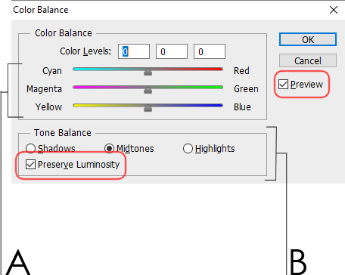  A. colour balance spectrum with sliders  B. tone balance

