Photography 11
Magnum PHOTO-HUNT
Go to the website magnumphotos.com
Explore different photographers using the drop down menu on the main page.

Be warned that, because this is photojournalism you may come across some disturbing images. Please use your own discretion when exploring certain photographer’s work and skip any that you feel uncomfortable viewing.

Copy each photo you choose into a word document. Label the photo with the title of the work (if possible), date, photographers name and the capitalized subject of your photohunt. Examples are provided for each topic.

PART 2

LIGHT

- Find an example of a photograph that uses natural BACKLIGHTING to create a silhouette
EG:
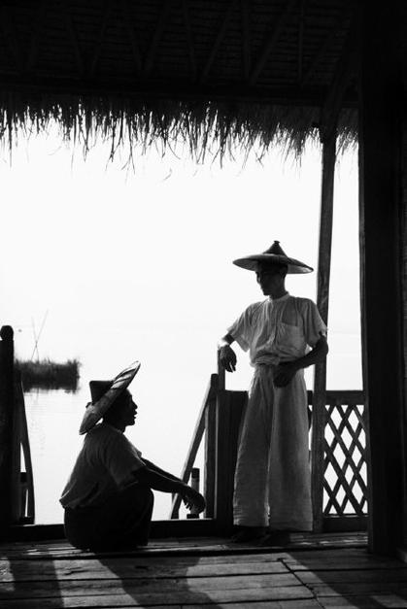
BACKLIGHTING
George Roger
BURMA. 1942. Shan States. A bamboo house built on stilts in the Inle Lake.

- Find an example of the use of AVAILABLE LIGHT to dramatically illuminate a face
EG:
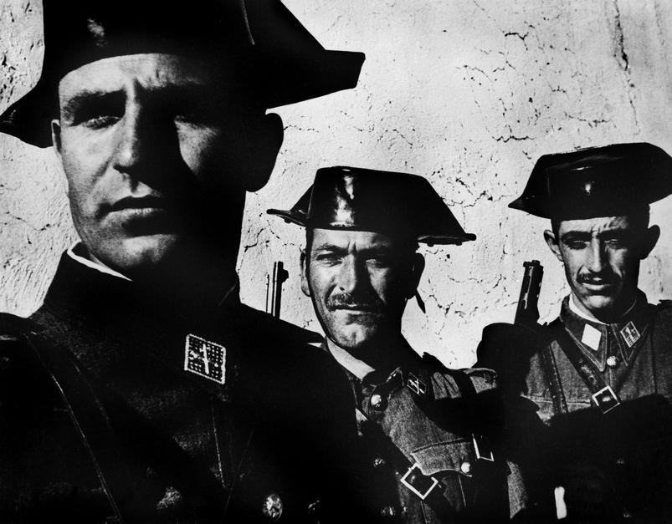
AVAILABLE LIGHT
W. Eugene Smith
SPAIN. 1951. Extremadura. Town of Deleitosa.

- Find an example of STUDIO LIGHTING used in a dramatic fashion:

EG:
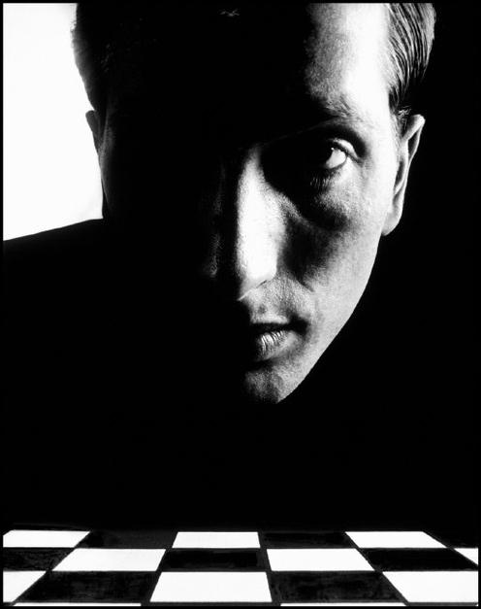
STUDIO LIGHTING
Phillipe Halsman
USA. 1967. New York City. Bobby FISCHER, American chess champion.

- Find an example that uses light to emphasize TEXTURE:

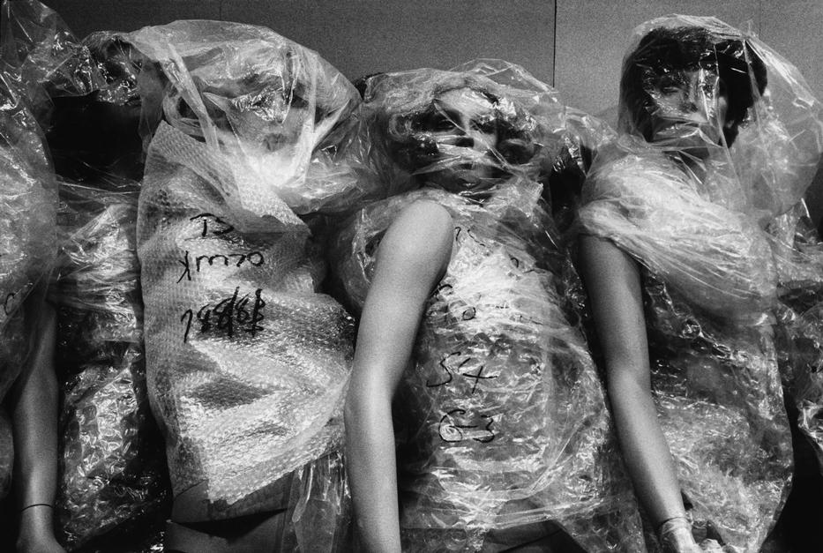
TEXTURE
Richard Kalvar
RFA. 1979. Cologne. Store window mannequins.

Give an example of dramatic use of SHADOW in a photograph:

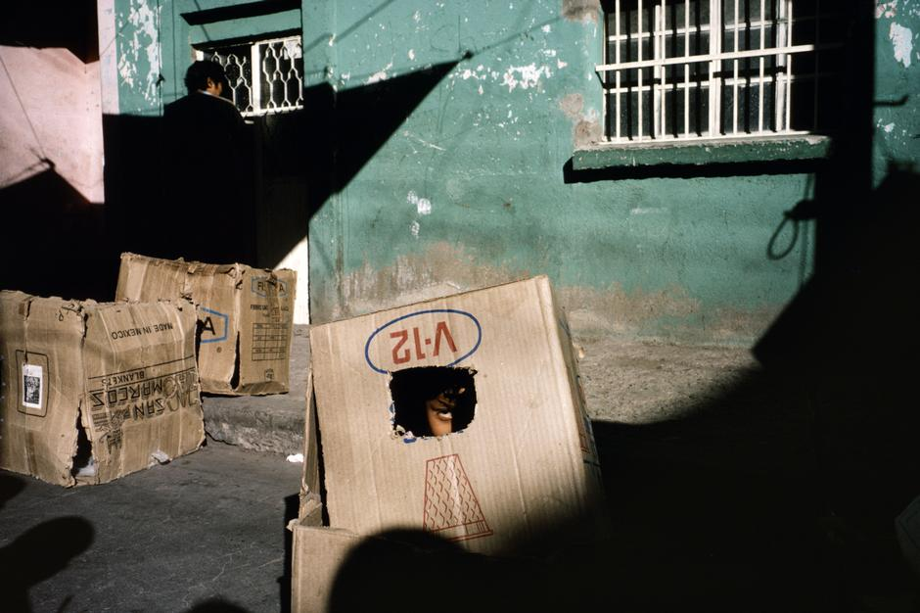
SHADOW
Alex Webb
MEXICO. 1987. Leon & Guanajunto.

