Assignment: Dry media drawing after Jim Dine

What: Complete a large drawing using the techniques that Jim Dine uses in his tool drawings.

Media: Conte and/or charcoal – any colour scheme on manila paper.

Content: What you draw is up to you, but you should choose something that resonates with you. This may be a drawing of an object, a person, a landscape, or it may be abstract. You MUST take your own photos for this project – you may not use any resources from the internet.
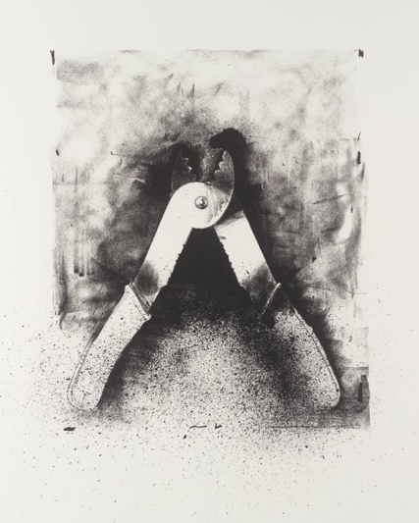
Focus:
- Value
- Texture
- Figure-ground relationship

Please submit:
- Your source material (in your sketchbook)
- Your drawing
- A short paragraph that explains the concept of your drawing (in your sketchbook)

Evaluation:
Approaching Expectations  (C-Range) | Meeting Expectations  (B-Range) | Exceeding Expectations  (A-Range)
Concept:
- You have generated your own source material.
- You have written a short paragraph that explains why you chose to draw what you did.

Technique:
- You have developed form through value
- You have a good range of value from light to dark
- You have used the materials to create texture.
- You have created an interesting figure-ground relationship.
- You have intentionally composed your image.

