3 Rules of Composition (Nevelson Piece)
Composition in a piece of artwork is incredibly important:
- It’s what catches the viewer’s eye and draws them in.
- Composition tells a story. You must consider where you want the eye to start and where you want it to end.
- It brings everything together in one cohesive piece - unity.

To achieve successful composition, you must include three things: A focal point, structure, and balance.
#1 Focal point
What is the viewer automatically drawn to? What do you want them to notice first? What is one CLEAR element in your piece? This is the focal point. If there isn’t a clear focal point, it’s often difficult for the viewer to understand the piece and the artwork can get boring.
So how do you distinguish a clear focal point?
• Main focus or details in a drawing or painting
• High contrast (using colour, size, shape, etc.)
• Motion
• Isolation
• Framing or cropping
#2 Structure
Having your focal point in the ideal placement can draw the eye to that area. This is a way for you to direct the viewer on where to start in your piece. There are many ways to structure your artwork but let’s start with one you may be familiar with, the rule of thirds.
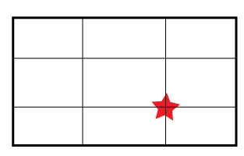
The Rule of Thirds
Basically, you’ll want to divide your piece into thirds. This can be done in your head or you can lightly draw in guidelines with your pencil. Your focal point should land on the intersecting lines. This will prevent you from automatically placing your focal point in the center, which most of the time we tend to do.

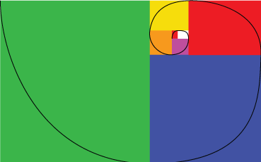
The Golden Ratio
If you check out the image to the right, you’ll notice that your focal point will be situated in the tiny part of the spiral. Your eye will start there in the center and work its way outward. This will create a pleasing flow in your artwork.

Symmetry
Symmetry works really well with architectural design - either horizontally or vertically. We mentioned earlier that your focal point shouldn’t be in the center of your piece but when it comes to architecture, it works well. (You might choose this for your Nevelson piece)

#3 Balance
Like so many parts of life, balance can be tricky. It is essentially the “right amount of each element. We want to be able to distribute the “weight” of each element. For example, if you have an area that has a lot of complicated detail, it needs to be balanced out with a place for the eye to rest – an area that is less detailed.

Once you have figured out the focal point, make sure you develop the background. A great way to check to make sure your piece is visually balanced is to squint your eyes when looking at the piece. Which elements pop out to you? While you’ll have your clear focal point, there should be other areas of interest in the piece as well.

Assignment: In your sketchbook, design your Nevelson project. Consider these rules of composition.

