CAMERA SIM.COM
Go to Camerasim.com https://camerasim.com/original-camerasim/

Select the “Manual” option (M)
Change the ISO to “400”
Move the lighting slider to “sunny”
The distance and focal length don’t matter too much. Set them to whatever you like.
Look at the bottom of the screen. It will show you your aperture and shutter settings as well as the light meter which will look like this:
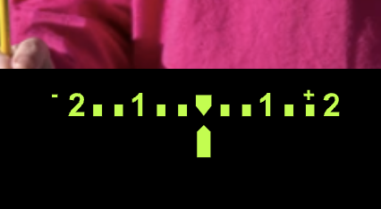
And change depending, of-course, on your settings.

Set the aperture to F-4.

- What do you have to change the shutter speed to in order for you to get a good exposure on your light meter? Why?

- Snap a picture. n Is the background clear and crisp or blurry? Why?

- Is the pinwheel blurry or clear? Why?

Now set your Aperture to F-16

- What do you have to change the shutter speed to in order for you to get a good exposure on your light meter? Why?

- When you take a photo with these settings is the background clear and crisp or blurry? Why?

- Is the pinwheel blurry or clear? Why?

Now change your lighting setting to partly cloudy or another “lower light” situation.

- What happens to your light meter?

- What needs to happen in order to get a good exposure again?

- Can you always select exactly what Aperture you want and what shutter speed you want? Why or why not?

