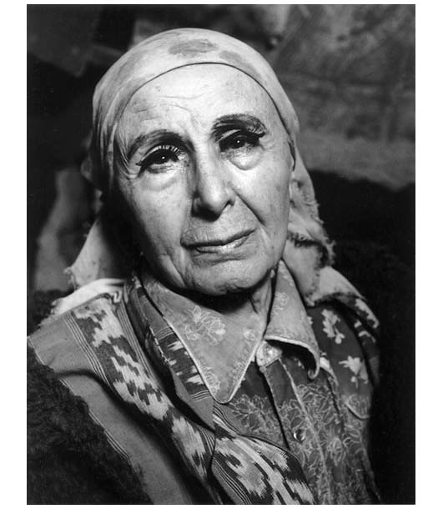
Assemblage Project After Louise Nevelson

For this project you will create an assemblage box much like Louise Nevelson, using only found objects. The box and its contents will be painted one colour at the end, creating a unified sculpture.

Steps in the project:

- Collect a lot of materials – recycling, boxes, egg cartons, plastic containers, etc.
- Play with the objects to discover how you can create interesting forms by cutting and shaping the objects.
- Create a composition in the box.
- You can add partitions to create boxes within the boxes if you wish.
- Once you have settled on a design and prepared all your objects, use hot glue to glue down your composition.
- Finally, paint your sculpture so that it is a uniform colour.
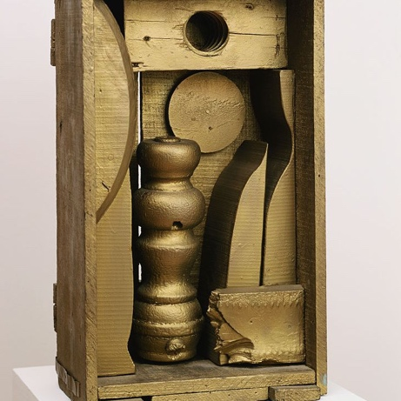
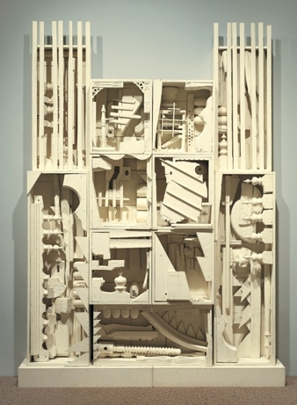
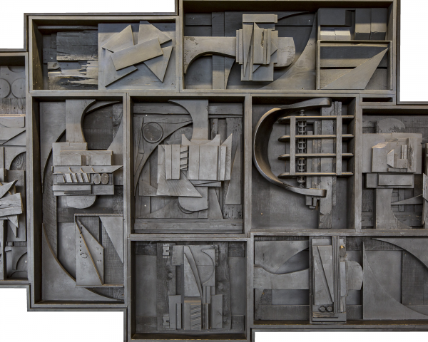

Minimally Meeting Expectations (C-Range) | Meeting Expectations  (B-Range) | Exceeding Expectations  (A-Range)
Composition:
- Designed in sketchbook
- Uses a rule of composition
Construction:
- A variety of objects create the forms in the box
- The box is finished cleanly – edges are smooth and intentional.
- Glue does not show.
- Paint is carefully and smoothly applied.
Studio Practice:
- Safety and clean up practices are followed.
Comments:

Minimally Meeting Expectations (C-Range) | Meeting Expectations  (B-Range) | Exceeding Expectations  (A-Range)
Composition:
- Designed in sketchbook
- Uses a rule of composition

Construction:
- A variety of objects create the forms in the box
- The box is finished cleanly – edges are smooth and intentional.
- Glue does not show.
- Paint is carefully and smoothly applied.

Studio Practice:
- Safety and clean up practices are followed.

Comments:

Minimally Meeting Expectations (C-Range) | Meeting Expectations  (B-Range) | Exceeding Expectations  (A-Range)
Composition:
- Designed in sketchbook
- Uses a rule of composition

Construction:
- A variety of objects create the forms in the box
- The box is finished cleanly – edges are smooth and intentional.
- Glue does not show.
- Paint is carefully and smoothly applied.

Studio Practice:
- Safety and clean up practices are followed.

Comments:

