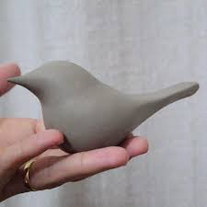
Project #1 – Birds!

For this project, you will hand build and decorate a hollow bird.

To think about: 40% of the worlds’ 11,000 birds are in decline and risk becoming extinct due to human actions. How do you react to this? You may interpret this in your own way, coming up with a design/imagery/pattern that conveys your idea.

Your bird will be about 15-20cm tall and decorated with additive sculpture, relief carving, and slip trailing.
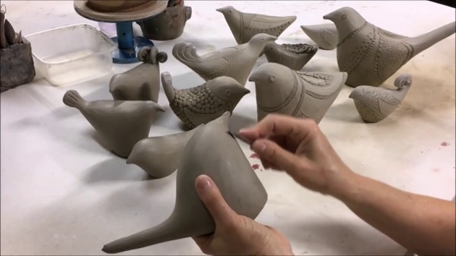

Steps in the project:

- You will be working with a basic design, but you can embellish it as you wish. Draw your design in detail. Check with Ms. Dodge that the design will work!
- Build the base of your bird as demonstrated. Keep the clay at a cheese hard stage in order to add and remove clay without affecting the structure.
- Be sure to put a hole in the bird at the end so that it will not explode in the kiln.
- Using a slip-trailing application, add more textural detail to the bird when it is leather hard. After this point it will be very fragile and should be dried slowly.
- Continue with careful glazing and finishing. Remember that you may leave areas of the bird unfired if you wish.

Vocabulary:
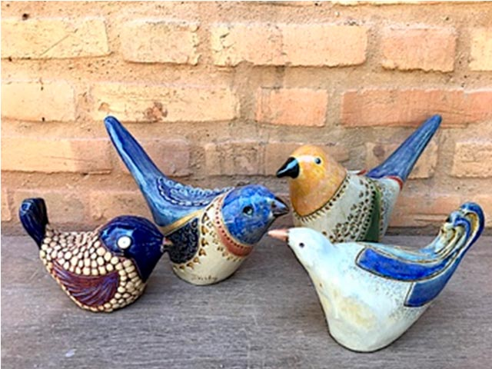
- Slip – liquid clay
- Slip-trailing – the art/practice of drawing designs using slip gently squirted through a nozzle.
- Slip-trailing bulb – a squeezable rubber bulb with an attached nozzle.
- Relief – the practice of removing material to create a design.
- Cheese hard clay – when clay is starting to dry, but can still be formed without cracking.

Evaluation:
Approaching Expectations  (C-Range) | Meeting Expectations  (B-Range) | Exceeding Expectations  (A-Range)
Design:
- You have designed a bird in your sketchbook.
- Your design relates to the idea of birds being threatened species.
- You came up with a title that gives your work meaning.

Building:
- Bird is symmetrical
- Seams are invisible
- There are areas of relief.
- There are areas that are built up.
- The design includes the use of slip trailing.
- The bird stands on its own.

Finishing:
- You followed safety/clean up instructions.
- You worked with the texture of your design when applying under and overglazes.
- The foot of your bird was wiped clean.
- You cleaned up your work area and took care of the slip trailing bulbs. (Thanks!)

