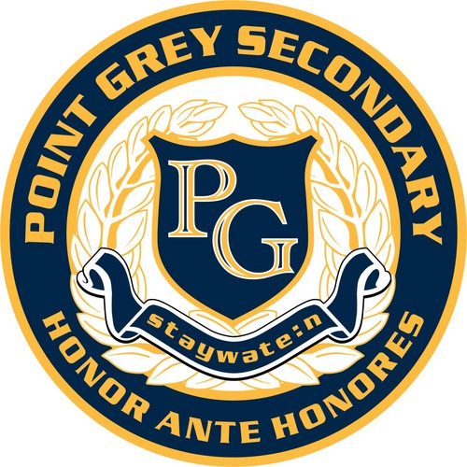
Art 8 – Rotation
Point Grey Secondary School - Room 309
Teacher: Ms. Heather Dodge
Email: hdodge@vsb.bc.ca
PG Art Website: https://pointgreydesign.weebly.com/

Art 8 is an introductory studio arts course designed for students enrolled at Point Grey Secondary School. The course focuses on introducing students to the world of art, creating artworks in personal and cultural contexts, and exploring art making techniques.

Projects

Students will complete assignments in drawing, painting, printmaking, ceramics, and sculpture. The emphasis is on skill development and personal expression. Students will keep a sketchbook of images, lessons, and plans for projects.

Required Materials

Materials will be provided to students in order to complete the assignments in this course. All students will be provided with a small sketchbook to complete their assignments in, and should bring a pencil and a white eraser to each class.

ART MATERIALS SUPPLEMENT FEE: $10 Due by Sept. 12th, 2019

Evaluation

Attendance and class participation are very important in Art courses because it is difficult to make up studio time. Students are expected to arrive on time for classes and events, and provide absence notes in the case of missed time. Students may be asked to make up absences during tutorial time, lunch, and after school. When in the art studio, students are expected to be mentally and physically prepared and on task. Phones are not to be used in class. Projects and assignments must be submitted by their due dates, and each will be evaluated holistically with emphasis on skill development.

 | Percentage of Term Mark
Studio work ethic and participation | 20%
Assignments | 80%

