COMMERCIAL DESIGN 11

ZINE!!!
(refer to the “How To Make a Zine” zine for further reference)

TOPIC
- The TOPIC of your zine can be whatever you want!
- Tell a story, write reviews, explore any unified idea.
- See examples for inspiration

CONTENT
- Your Zine must contain at least 8 pages including the front and back cover (but this is bare minimum)

- Your zine must be in black and white if you want Mr. Long to do photocopying for you. If you want a colour cover (or even colour pages inside) you may but you will be responsible for the photocopying.
- It must include both text and imagery
- It CAN include drawings, found objects, collage photographs, hand-writing and lettering, type etc.

- Your teacher may or may not (circle one) allow you to use Photoshop to manipulate images.

- Your zine must have a cover and a title and author/artist credit

LAYOUT
- You must establish a consistent grid format to use when composing/constructing your layouts.

- Your layouts must therefore conform to this grid meaning that all objects are aligned to it.

- Create a template in Indesign according to our instructor’s instructions. Include a bleed, margins and columns to accommodate your grid format.

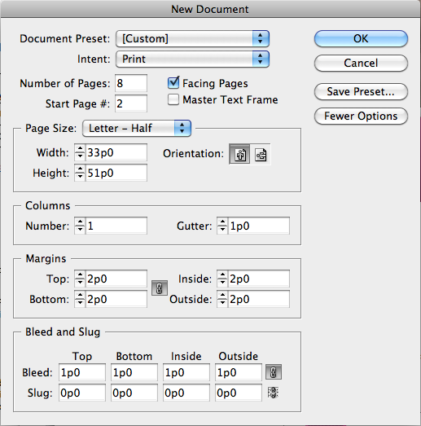

- You will have to design/arrange your panels for hand-in and printing as follows:
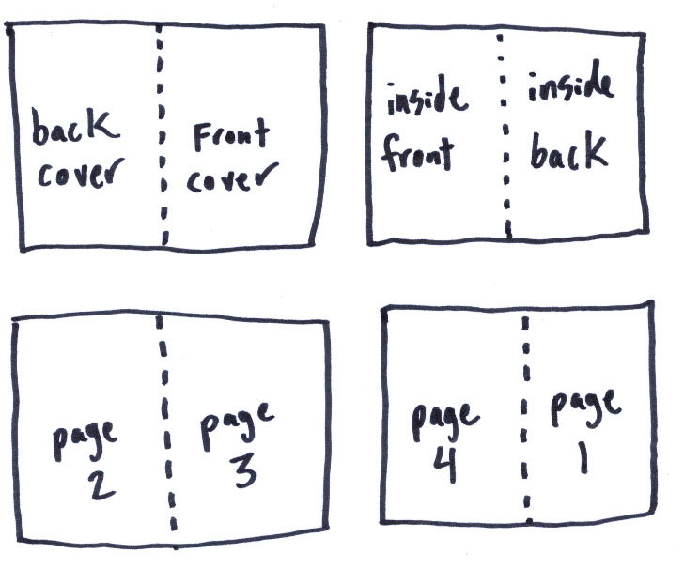

- Feel free to allow for negative space on your pages to allow content to “breath”

PRODUCTION
- Your zine must be handed-in in 8.5” x 11” format and be completely ready to photocopy.

- Binding options are your choice.

- You must produce at least 5 identical zines for submitting, trading, distributing and keeping.

EVALUATION
/10 - TOPIC – is well-explored, creative and unified
/10 - CONTENT – All criteria is addressed and design is considered, interesting and unified.
/10 - LAYOUT – All pages conform to grid format. All content is aligned etc.
/10 - PRODUCTION – production of zine is considered and professional. Fulfills all criteria.

