GRAPHICS 10

WORKING WITH GRIDS

Get a sheet of grid paper from Mr. Long.

Use the diagram below of 3 column grid variations as an example for what I want you to do.

Like the top left diagram in the illustration below (second one down), create a basic grid composition with anywhere from 4 to 9 columns.

Make sure you compose your grid with appropriate margins. Each square in your composition should be at least 3 or 4 times the width of your margins.
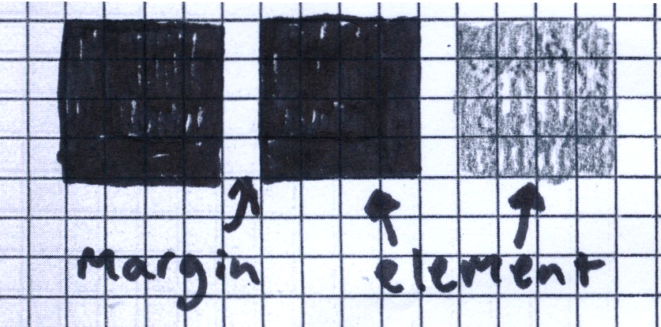

Now, using a combination of 2 shades or colours and negative space, create at least 8 variations of the grid composition that you have chosen. Of course each element, including your negative space (space is an element!) should correspond with your chosen grid format.

presentation, execution and composition of assignment are important.

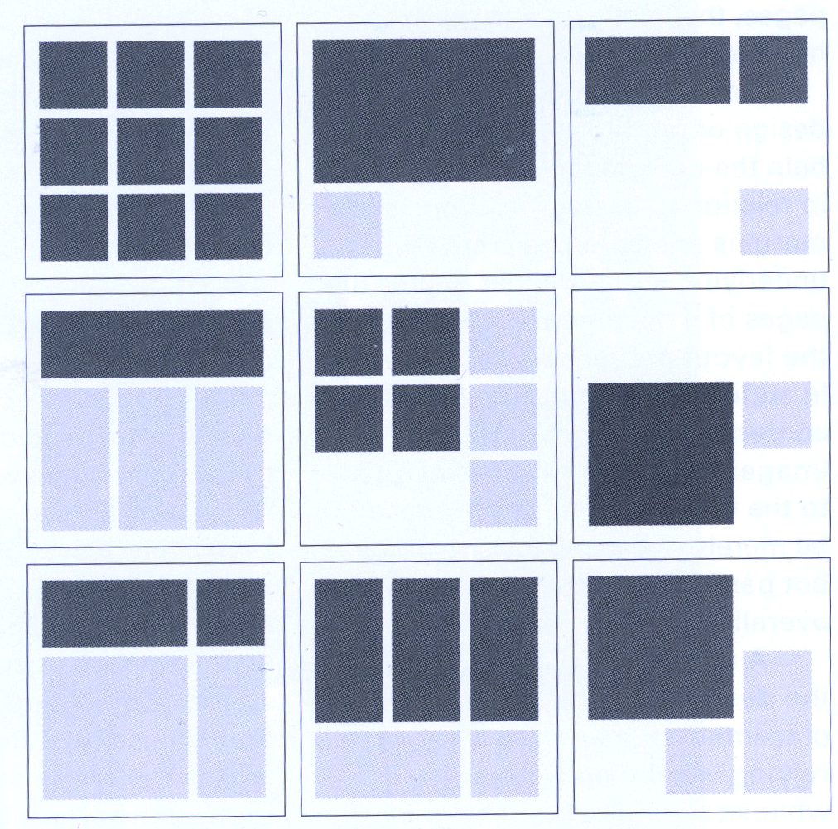

Now: choose your favourite, most dynamic composition and create a large format (8.5” x 11”?) composition using images cut from magazines, grey paper (for text blocks) and negative space.

