Project #2 – Two Part Stencils Using Spray Paint

For this project, you will develop a simple design to be cut into a 2-part stencil, and completed with spray paint. It will have two colours.

This video shows the exact process: https://www.youtube.com/watch?v=4lX30mw9518

Concept: the stimulus for this project is the idea of “weeds.” You may interpret this in your own way, coming up with an image/symbol that conveys your idea. Take the time to think about this carefully!

Your image will consist of a coloured background, with darker “drawing” laid on top.

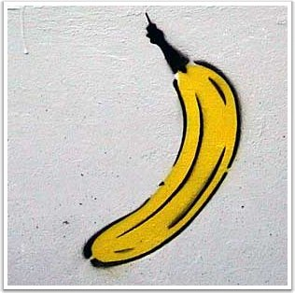
Steps in the project:

- Decide on a design that reflects your idea of “weeds.” It must fit on a regular sketchbook page. Check with Ms. Dodge that the design will work!
- Choose two colours to work with – one should be the background colour, the other the line colour.
- Transfer your drawing onto one of your stencil sheets using a large black Sharpie. Make sure that there are bridges to all the islands in your work.
- Using a very sharp X-acto, cut out all the Sharpie lines. Go slowly. If your blade begins to tear the paper, STOP! Fix the problem before continuing.
- Once you have cut out the first stencil, line it up perfectly on your second stencil, and lightly spray through it. (Use the spray booth.) Lay your stencil flat to dry. The spray paint shows you exactly where you need to cut on your second stencil.
- Cut all around the linework on your second stencil. This stencil will be the background colour.
- Line your background colour stencil up on your artwork paper. Spray your background colour. Carefully remove your stencil and let both the stencil and the artwork dry flat.
- Once the background colour is dry, line up your linework stencil on your artwork paper and spray your second colour through it. Lay it all flat and let it dry.
- Write a title that gives your work meaning, or helps the viewer understand your idea.
- Smile and be proud!
Evaluation:
Approaching Expectations  (C-Range) | Meeting Expectations  (B-Range) | Exceeding Expectations  (A-Range)
Design:
- You have chosen and created a recognizable image.
- Your image relates to the idea of “weeds”
- You came up with a title that gives your work meaning.

Stencils:
- You drew your image accurately.
- You cut your linework stencil by following the Sharpie lines.
- Your cuts are clean, without feathers or tears.
- You sprayed your linework stencil to show where to cut your background stencil.
- You cut your background stencil accurately.
- Your two stencils line up with each other.

Final Image:
- You followed safety instructions.
- You sprayed the background colour first.
- You sprayed the linework stencil second.
- Your image is lined up well and pops out at the viewer.
- Your spray is applied without drips or too much overspray.
- You cleaned up your work area and took care of the spray paint nozzles. (Thanks!)

