INSTANT PHOTO ZINE

(You can actually make this zine with any images you want!)

- Create a Photoshop document that is 8” high by 10” in length and 300 dpi.
- Drag guidelines (click and drag from the rulers at the edge of your document onto your image space) horizontally to the 4” mark and vertically to the 2.5”, 5” and 7.5” marks. Like this (but neater):
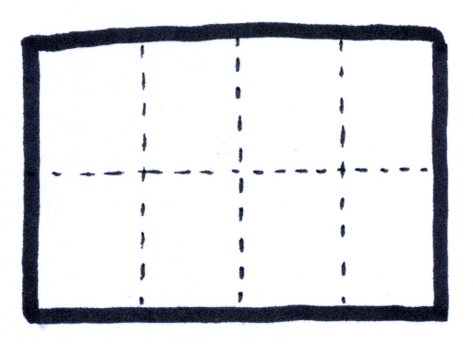
- Choose 8 of your photos (either from the photo-hunt project, pinhole camera project or otherwise) that you think would look good in black and white.

- Open them in Photoshop.

- Adjust the size so that the largest dimension is 4” (Image>image size)

- While you’re at it make sure that the DPI is the 300dpi (same as your new document)

- Desaturate each one (image>adjustments>desaturate)

- Adjust the contrast of each image (it will look better with high contrast) in Image>adjustments>levels.
- Select the crop tool and, from the top corner, drag a 2.5” x 4” selection. You can now move this box around the image until it shows a cropped image that you are happy with. Press return to execute the crop function.
- Save as: ______________ to your USB drive. Do this to all 8 of your images.

- Decide on an image that you will use for your cover. Come up with an appropriate title for your zine and, in Photoshop, add your title and author credits (your name). Think about placement (composition), font or text style and legibility (can you make out what it says? (you could also do this once you have placed all images into your zine document)

- You may want to decide where they go first (you could make a little maquette) and rotate the images so they will be the “right” way up when you copy and paste them into your zine document (see below).

- one by one place them in order on your 8” x 10” document (select all> copy>paste). Make sure that the bottoms are facing the center of the page while the tops are at the edges and that you place your images in the appropriate order as per diagrams below:
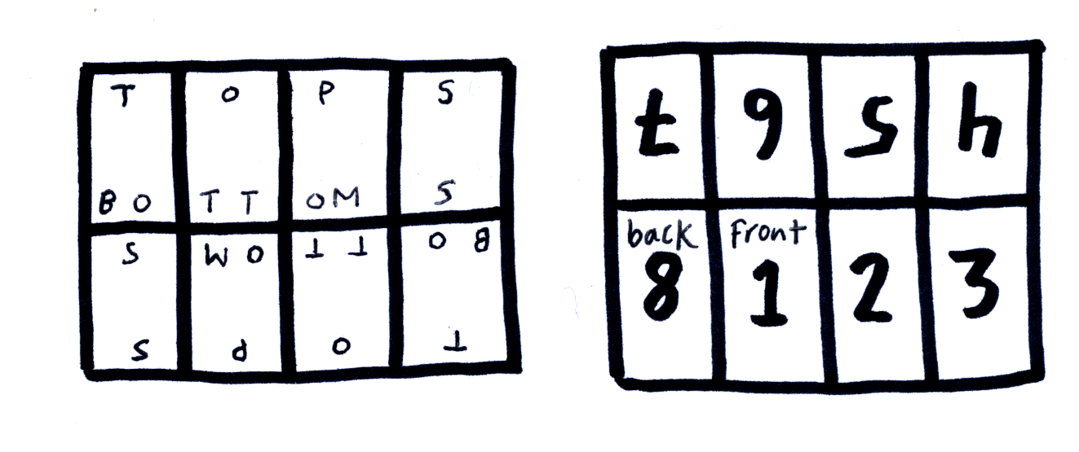

- You may also want to use your magnifying glass tool to make sure you have placed all your images properly (no spaces in between people!)

- Save as a Photoshop document onto your USB drive so that you have a document with all layers open and adjustable.

- Flatten the image and Save As a jpg document (so the size of the file is smaller and more manageable (You should now have to versions of your project saved to your USB drive.)

- Print out the Jpg version and trim the white borders neatly.

- Carefully cut the section indicated in the diagram below with an X-acto knife.
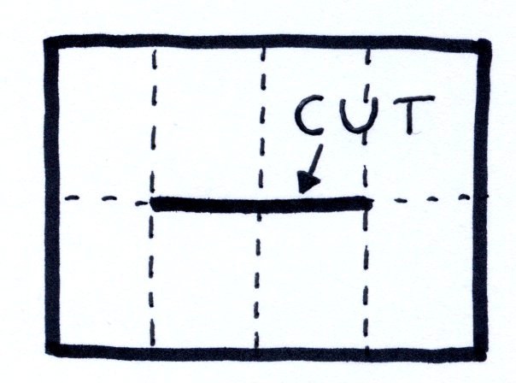

- Now carefully fold in accordance with diagrams below:
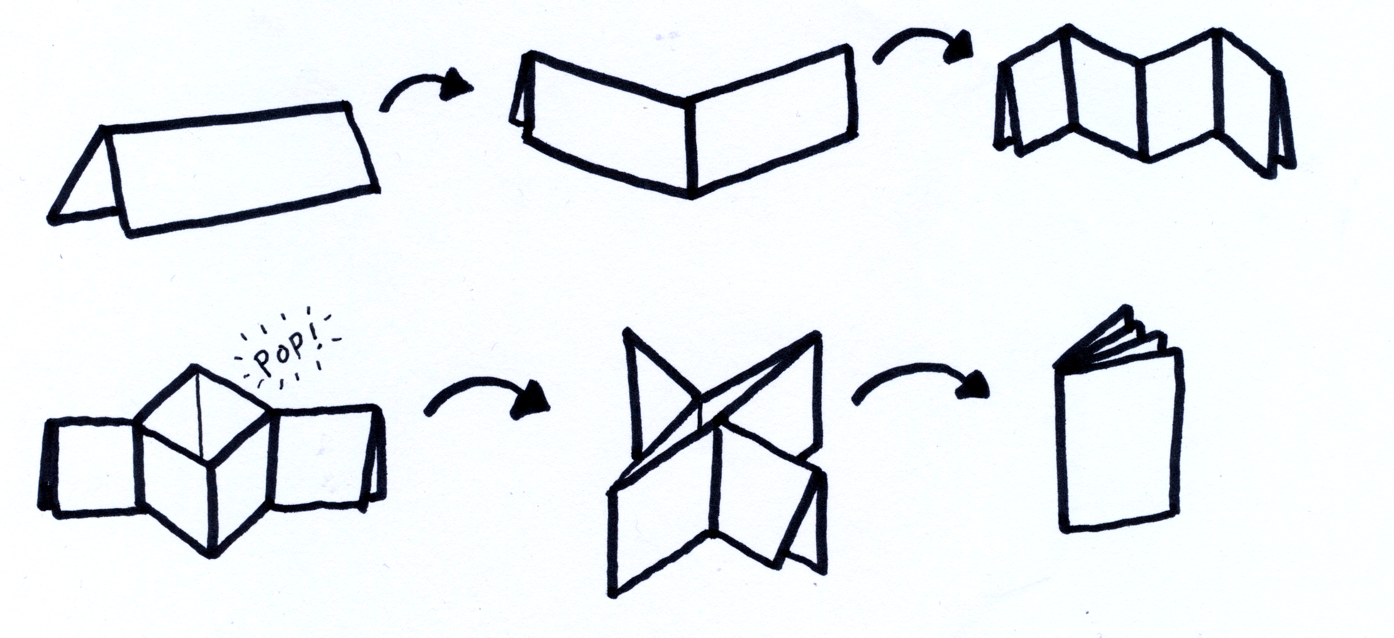

COOL!

Evaluation:

Images: are proper resolution, have good contrast, are well chosen (they are well composed, interesting and go well together.
/10

Presentation and Execution: All images are placed neatly and evenly within your document. All cutting and folding is neatly and accurately done.
/10

Text: Cover text is well considered, well placed compositionally and legible.
/5

Total
/25

