PHOTO PROMPTS

STRATEGIES AND IDEAS FOR TAKING COOL PHOTOS

#1
SEE THE LIGHT

Photography IS light.

Look for light shining, seeping, peeking into dark spaces, through objects and onto objects.

Where is the light coming from? The sun? Outside or inside? Is it man-made light? Did you place the light there? What is the light falling on? What pattern or shape is the light creating? What areas of shadow or darkness?

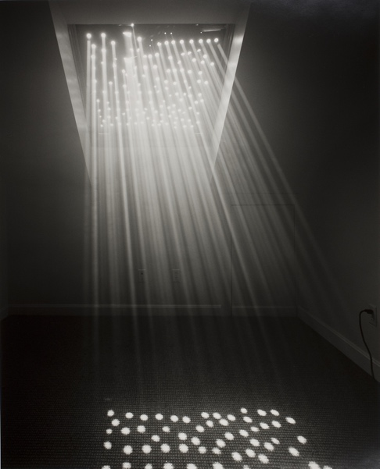
Check out:
Abelardo Morell’s Light Entering Our House, 2004.

or this amazing image by Paul Strand

