PHOTOGRAPHY 11
Photoshop: Levels Adjustment and Colour Balance

WHAT IS LEVELS ADJUSTMENT?

Levels adjustment can be used to adjust tonal range and the contrast of an image by adjusting intensity levels of image shadows, midtones, and highlights.

To find levels adjustment go to the menu bar > Image > Adjustments > Levels (or CTRL+L/Command+L) and an adjustment box with a histogram will pop up (image on the right)  A. shadow slider (black arrow): controls the level of shadow; the more the slider shifts right, the greater darkness.  B. midtone slider (gray arrow): controls the level of midtones; shifting left makes it lighter, shifting right makes it darker (works similarly to “exposure”).  C. highlight slider (white arrow): controls the level of highlights; the more the slider shifts left, the greater the highlights.  D. output slider: maximum dark and maximum highlight allowance in your image. | 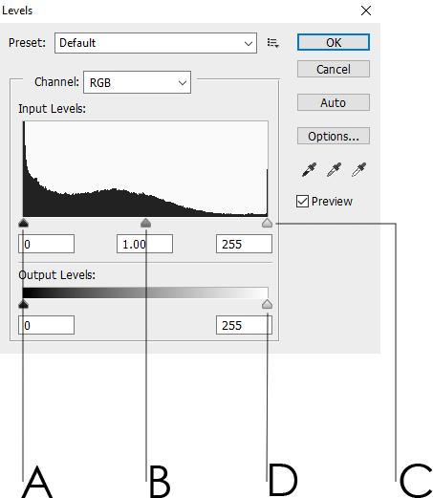  A. shadow B. midtones C. highlights = input  D. output level sliders = output

