PERSONS OF INTEREST
PAMPHLET DESIGN

Your assignment will be to create an informational pamphlet about a person of interest or import. One side of the design will contain the information: photographs and writing illuminating your readers, and the other half will be a poster: eye-catching, dynamic and beauteous!

Try to choose someone that you are very interested in, will be researchable and perhaps will be a unique and original choice. Your subject can be a musician, actor, philosopher, author, artist or any other notable person.

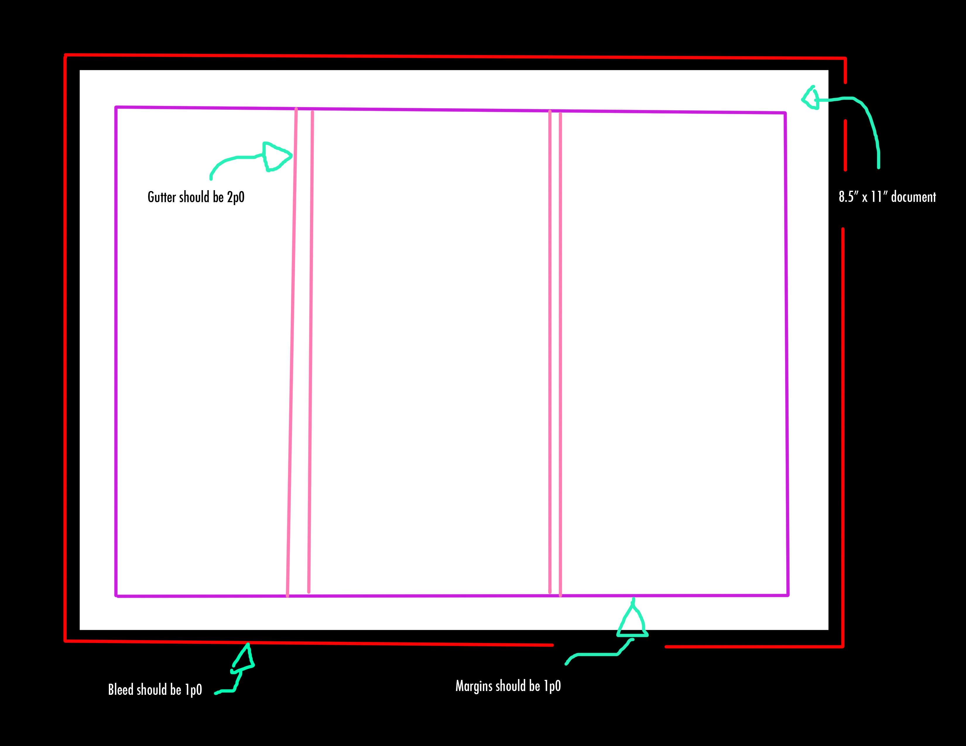
INDESIGN TEMPLATE
- Start by creating an Indesign file with the following document settings.
- You will be using this template for both sides so make sure you “save-as” after you use it for one side or the other so that you retain the original template

SIDE 1: POSTER

- Create a poster with an image or images as well as a bold title that is contained within the far right column of your template. The far right title column should work both as an isolated composition (a cover for the folded pamphlet) and also as a component of the overall poster composition (the unfolded side 1 of the pamphlet).
The title can be either horizontal (but it will have to be smaller) or vertical (of course it can be bigger to fit with the size and shape of the pamphlet cover.
- Think about balancing your composition. How will you balance the strong compositional weight of the text on the right side of your poster?
This presents a fairly unique design problem in that, rather than the convention of placing the title at the top or center, the title will have inhabit the far right 1/3rd poster. It will be a large (possible vertical) element on the right side of a horizontal poster. Maybe the imagery is stronger on the left side to balance out the strong compositional element of your text – OR – you include other text elements on your poster to balance out the title.
- If you choose to include more than one image element on your poster make sure that it conforms to the column guides.
You are free to deploy any other design elements within the poster/cover design as long as they do not over power the photography and text elements and maintain harmony (don’t overdo it!)
- You may compose this entirely in photoshop (but you must eventually place it in your Indesign template). Use pulled guidelines as guides for your columns.
- You may use layer masks or any other interesting effect for your title. Remember that contrast will be important for legibility.
Title design may include opaque, translucent or inverted text. Colour block elements with text overlay, or layer masks (possibly creating negative space text windows within the colour block element. (see slideshow)
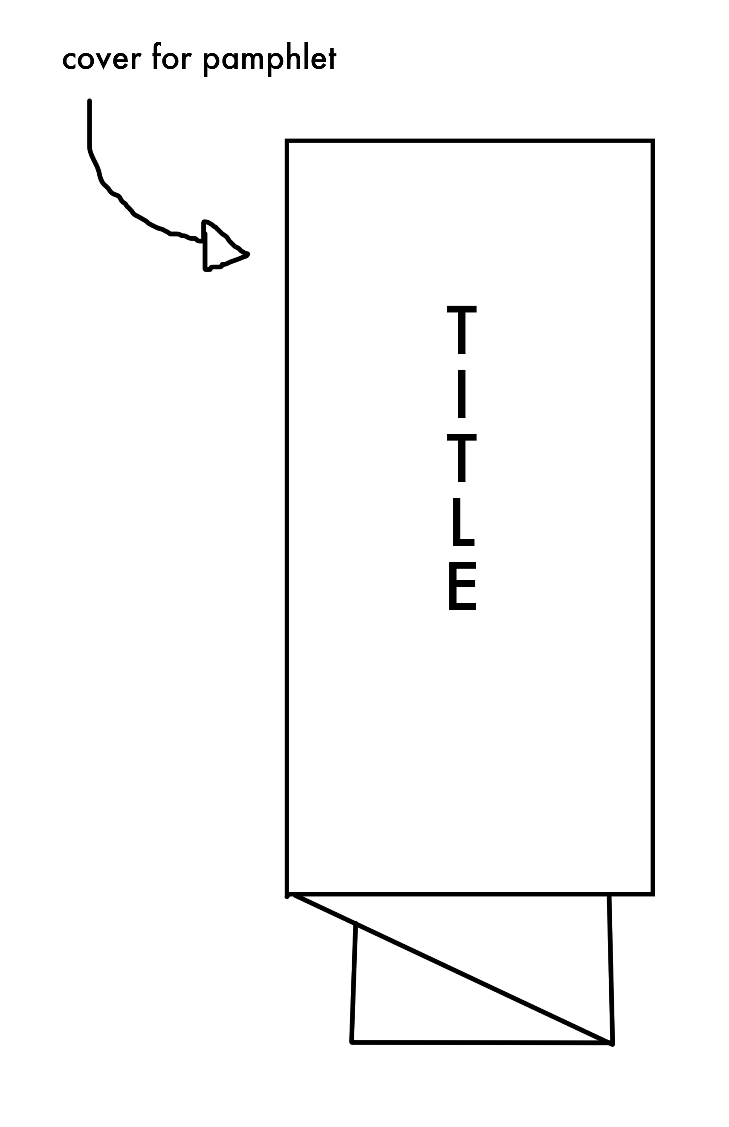
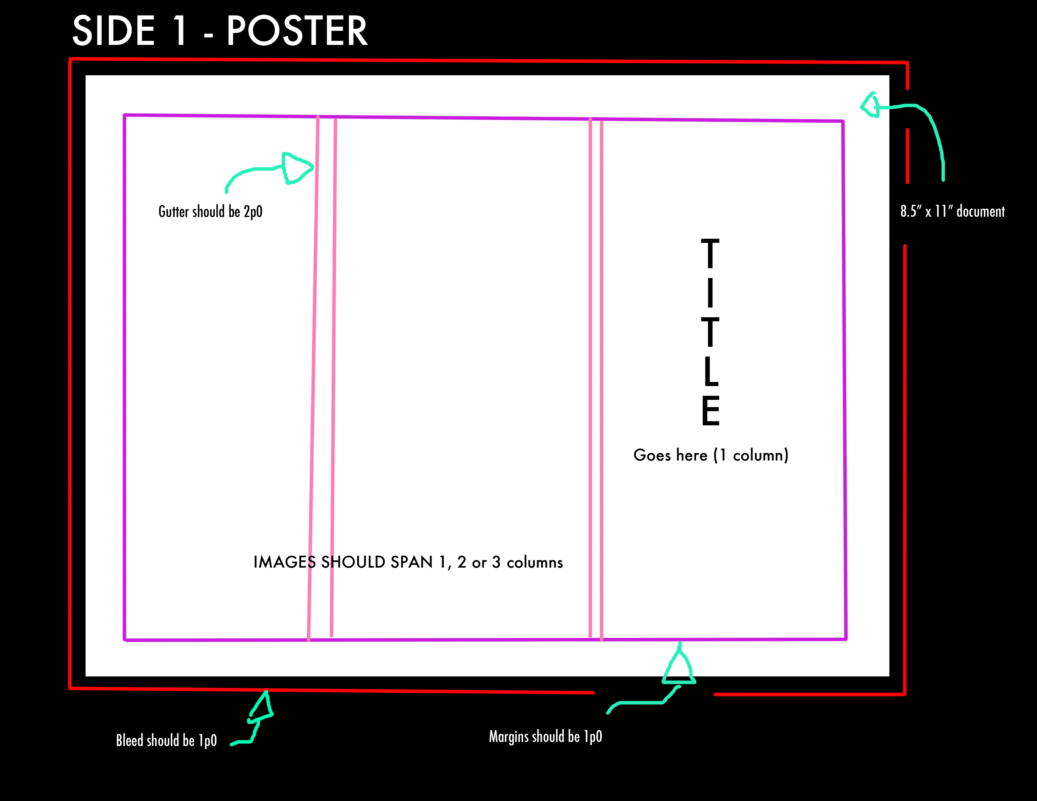

SIDE 2: PAMPHLET

- Again working with the three column grid design a layout with content related to your chosen subject.
- You must have:
  - A heading, similar of mirroring the design for the cover (remember: UNITY)
  - three photos, with one being dominant
  - a written portion that should include
    - a short appreciation of… (prose)
    - a list of facts
    - a list of accomplishments, notable works etc
    - feel free to be creative with this and customize the content to fit with your subject or your own interests. What is important is that you have multiple types of written content/elements.
- Think about colour: elements, background etc.
- Think about the inclusion of negative space as an important element of your design.
- Your teacher may determine this to be a colour or black and white assignment.
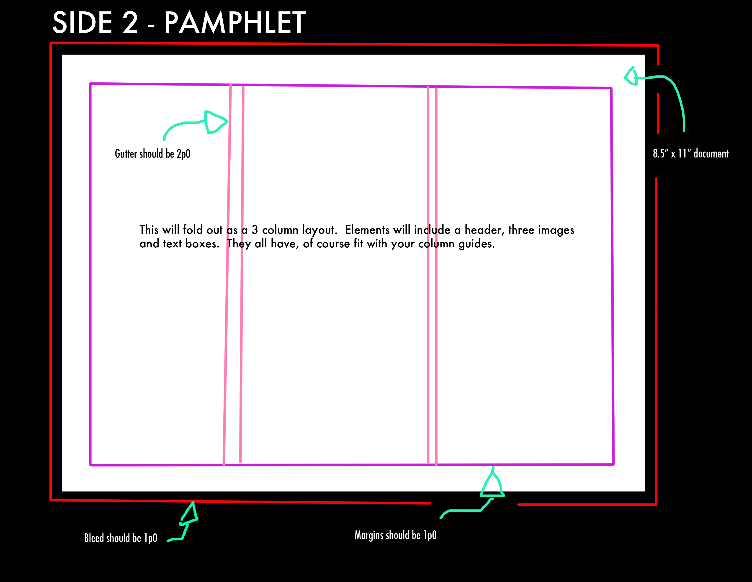
- Include any other design elements that you wish but remember to keep it fairly simple and elegant.
- Export both the poster side and the pamphlet side to PDF.
- Open Adobe acrobat and select File>create> combine files into a single PDF.
- In the pop-up that appears choose your two pdf files.
- Press file>print and select:
  - Actual size
  - Print on both sides of paper
  - Flip on short edge
- Print to the mac lab black and white printer first to make sure that all your spacing, sizing, margins etc are correct, and to practice trimming and folding.
- Once you are confident print in the same manner onto the teacher colour printer.
- Once printed trim, fold and submit per teacher instructions.
- You may also be required to submit digitally as well.

