Painting and Drawing 12
Point Grey Secondary School - Room 309
Teacher: Ms. Heather Dodge
Email: hdodge@vsb.bc.ca
PG Art Website: https://pointgreydesign.weebly.com/

Painting and Drawing 12 is a senior studio arts course designed for students who enjoy art and are interested in the subject. The course focuses on creating, viewing, and reflecting on artworks in personal and cultural contexts.

Projects

Students will complete a variety of assignments in drawing, painting, 2D design and printmaking. The emphasis is on skill development and personal expression.

Art Viewing and Critique

Students will visit galleries and other art exhibits throughout the year, studying and applying viewing and critiquing skills. Students will be required to talk and write about their own work, and the work of other artists.

Required Materials
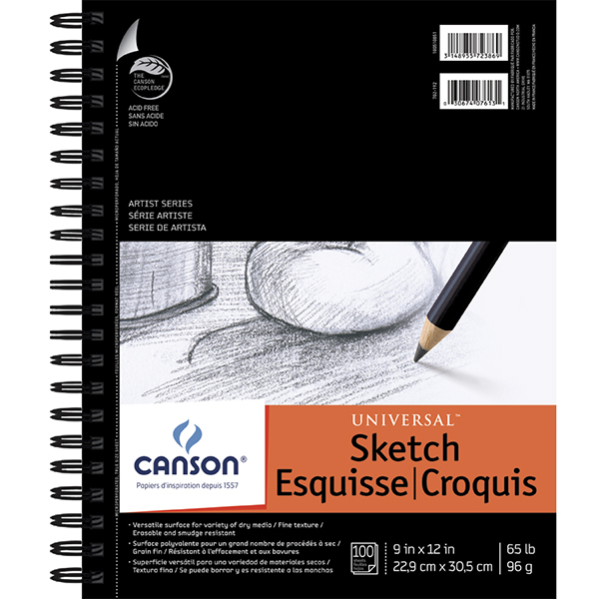
This year, students are required to use a sketchbook in class. Sketchbooks should be approximately 9X12” with a quality binding or coil. They are available at any art or office supply store. The example on the left is available at Opus Art Supplies for about $10, but any similar sketchbook will work.

Students may use all other art room supplies for their projects. Senior students will benefit from having their own kit of:
- a set of graphite pencils
- an eraser
- a small set of watercolour paints, a set of markers, or a set of coloured pencils
- black fineliner

ART MATERIALS SUPPLEMENT FEE: $30 Due by Sept. 13th, 2019

Evaluation

Attendance and studio practice are important in Art Studio 12. Students are expected to arrive on time for classes and events, and provide absence notes in the case of missed time. Students may be asked to make up missed studio time and attend events outside of school time. When in the art studio, students are expected to be mentally and physically prepared and on task, and keep phones out of sight. Projects and assignments must be submitted by their due dates, and each will be evaluated holistically with emphasis on skill development.

 | Percentage of Term Mark
Studio work ethic and participation | 20%
Assignments, including sketchbook work | 80%

