Photography 11
Magnum PHOTO_HUNT

Go to the website magnumphotos.com
Explore different photographers using the drop down menu on the main page.

Be warned that, because this is photojournalism you may come across some disturbing images. Please use your own discretion when exploring certain photographer’s work and skip any that you feel uncomfortable viewing.

Copy each photo you choose into a word document. Label the photo with the title of the work (if possible), date, photographers name and the
PART 2

Composition

- Find an image that effectively uses COMPOSITIONAL FRAMING.

Visual framing occurs when the subject of the image is “framed” or isolated by other visual elements within the image.
Eg:
Elliot Erwitt, USA. 1983. East Hampton, New York.

- Find an image, with more than one subject, which has a DYNAMIC SYMMETRICAL composition (no portraits).

Dynamic symmetry occurs when two elements within a composition visually balance each other, even though they may be of different sizes shapes or colour.

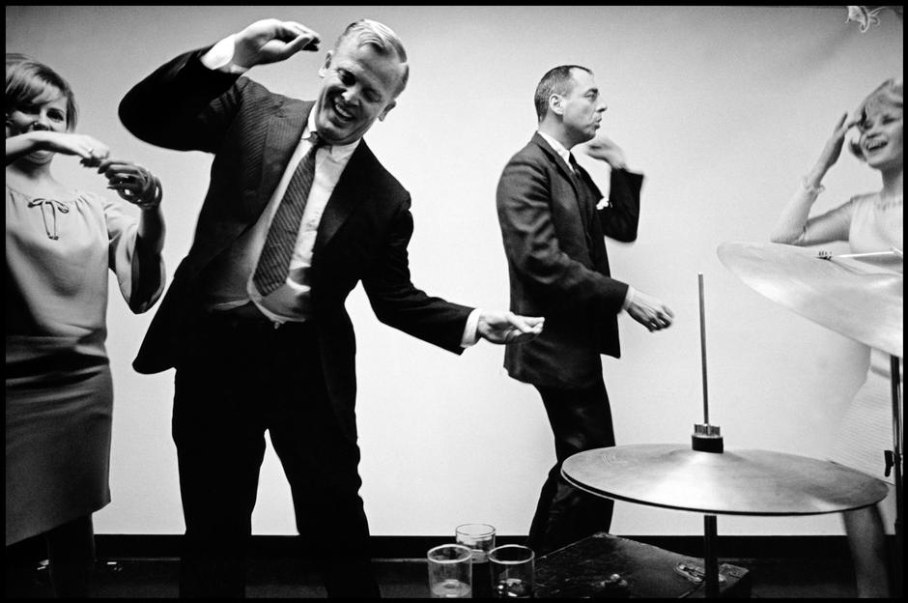
Eg:
Leonard Freed, USA. 1966. New York City. Office party.

- Find an image that incorporates PATTERN as the primary component of compositional interest.
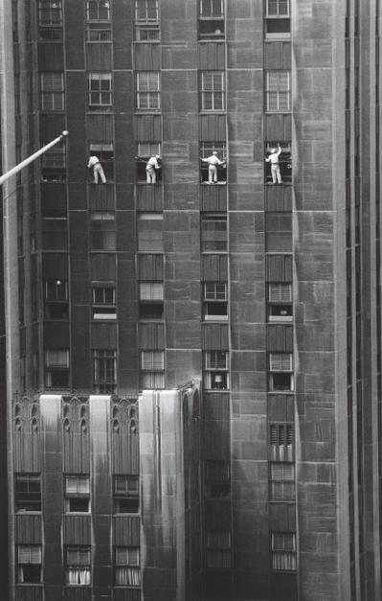
Eg:
Inge Morath USA. New York City. 1958. Forty-eighth Street window washers.

- Find a composition that uses LEADING LINES a primary compositional tool.

Photographers often find lines within a scene and compose the photo so that those lines lead a viewers eyes through a composition. These are called Leading Lines.

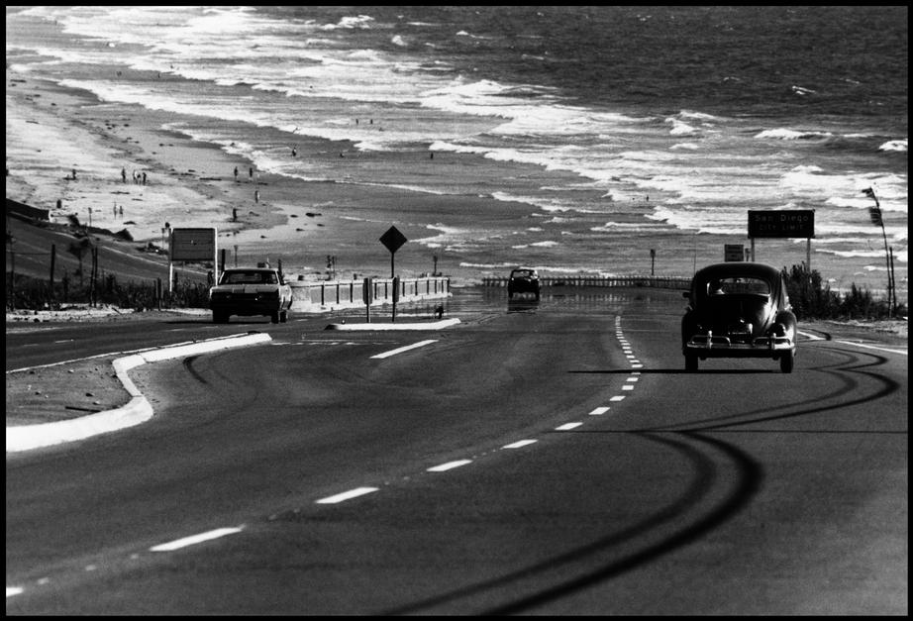
Eg:
Dennis Stock, USA. 1968. California. "The California Trip". San Diego Coastline.

- Find an image that is taken from an UNUSUAL VIEWPOINT.

Eg:
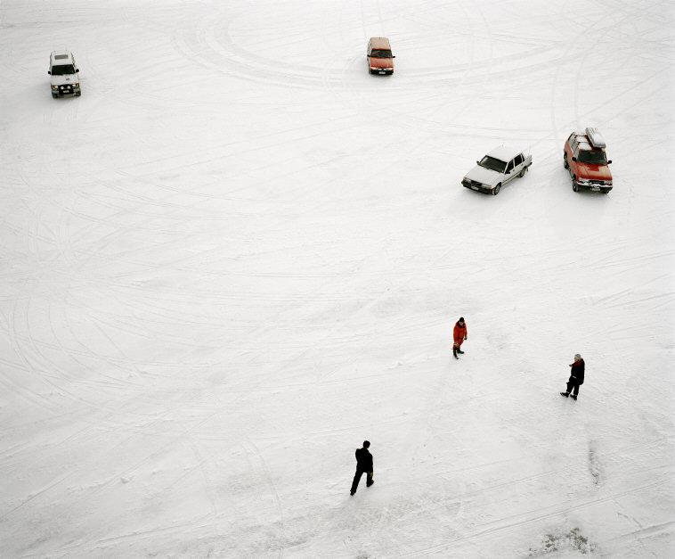
Mark Power, FINLAND. 2002. Bay of Bothnia. Pietarsaari. From the series 'Icebreaker'

