Project #4 – Perspective Drawing: Fear coming at you!

For this project, you will create a perspective drawing of a school corridor in one-point perspective with something you fear coming at the viewer.

Concept: the stimulus for this project is the often used “corridor” scene in movies, especially horror movies, where an evil thing is catapulting down a corridor straight at the viewer.
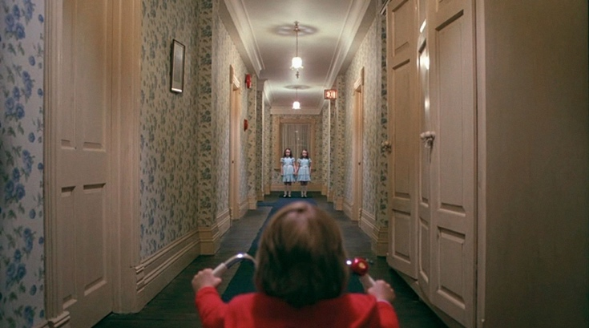
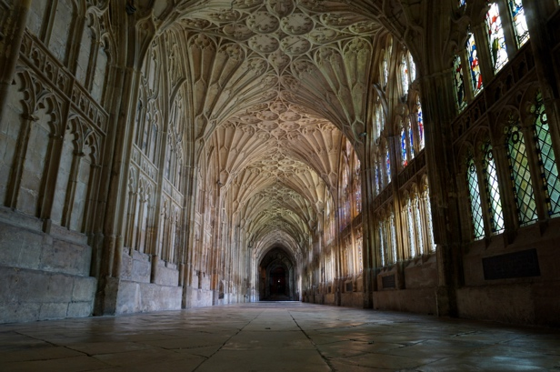

Your image will consist of a perspective drawing with the fear in the centre. We will use a base of corrugated cardboard that is roughly painted with flat, neutral paint.

Steps in the project:

- Choose a corridor in the school and make a rough draft in your sketchbook of what you’ll draw.
- Choose a fear and practice drawing it. Decide how close in the corridor it should be.
- Lightly and carefully draw the corridor in one-point perspective on your cardboard support. Decide which way the corrugation will go!
- Using a very sharp X-acto, cut out or tear away some sections of the cardboard. Go slowly. Stop regularly and check that you’re not pulling away too much cardboard.
- Working on brown paper, draw your fear using the media of your choice.
- Cut all around the fear and glue it very carefully onto your cardboard.
- Complete your perspective drawing with media of your choice, paying close attention to making it look good while still keeping it in perspective.
- Once the background colour is dry, line up your linework stencil on your artwork paper Add a little colour if needed.

Evaluation: Perspective Drawing Fear Coming at You!
Approaching Expectations  (C-Range) | Meeting Expectations  (B-Range) | Exceeding Expectations  (A-Range)
Perspective:
- Vanishing point is correct
- Vertical/horizontal lines are accurate
- Proportional Spacing is used
- Guidelines are erased

Fear:
- Your fear is accurately presented
- Fear is approaching viewer

Materials:
- You have experimented with cutting and tearing into the cardboard.
- You have used the corrugations of the cardboard for effect.
- You have chosen media that completes and emphasizes your drawing.
- You *might have added some colour.
- Your fear drawing is carefully and neatly glued on.

