Grade 8: Independent Sketchbook Drawing

For this assignment, you will do some independent sketchbook work to explore your creativity and practice your drawing skills. You must complete 6 activities. Fill the pages! Each drawing should take about an hour to complete well. You should be trying to apply the techniques we’re learning in class. It will be marked for effort and completion. Due at the end of the rotation.

- Draw your room. Sit in one spot and draw what you see, including the lines that show the ceiling, wall corners, doors, and windows.

- Draw someone you know who is sitting quietly.

- Draw your family pet.

- Imagine an alien pet and draw what it would look like.

- Fill a page with drawings of live plants.
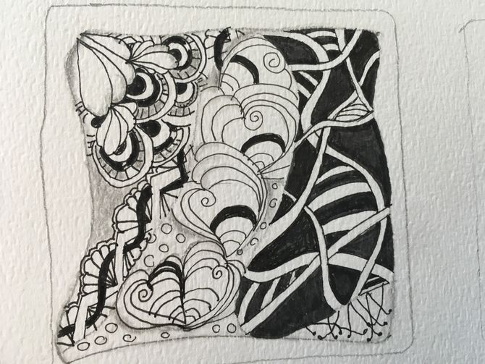
- Complete a Zentangle doodle for colouring. Fill the entire page. Use black marker/fineliner. Colour it.

- Throw a pair of jeans over a chair and draw what you see.

- Draw a dream you had – fill the whole page.

- Draw yourself at age 90, surrounded by the things that made your life whole.

- Create a collage using magazine images and a glue stick.

- Create an artwork inspired by the lyrics of a song.
Grade 8: Independent Sketchbook Drawing

For this assignment, you will do some independent sketchbook work to explore your creativity and practice your drawing skills. You must complete 6 activities. Fill the pages! Each drawing should take about an hour to complete well. You should be trying to apply the techniques we’re learning in class. It will be marked for effort and completion. Due at the end of the rotation.

- Draw your room. Sit in one spot and draw what you see, including the lines that show the ceiling, wall corners, doors, and windows.

- Draw someone you know who is sitting quietly.

- Draw your family pet.

- Imagine an alien pet and draw what it would look like.

- Fill a page with drawings of live plants.
- Complete a Zentangle doodle for colouring. Fill the entire page. Use black marker/fineliner. Colour it.

- Throw a pair of jeans over a chair and draw what you see.

- Draw a dream you had – fill the whole page.

- Draw yourself at age 90, surrounded by the things that made your life whole.

- Create a collage using magazine images and a glue stick.

- Create an artwork inspired by the lyrics of a song.

