GRAPHICS 10
HOMAGE TO THE SQUARE (after Josef Albers)
COLOUR THEORY

Look at examples of Josef Albers Homage to the square.

Notice how he creates harmonious colour combinations through layering squares of analogous colours.

Notice how he uses varying hues and values of the same colour along with analogous colours.

Notice how he often adds a contrasting or complimentary colour in order to emphasize the primary colour scheme.

ASSIGNMENT:

- Create 2 Homages to the square with 4 layers of colour each.
- They can be any size you want.
- Mount them to a piece of black card.

- Should be analogous colour scheme only.
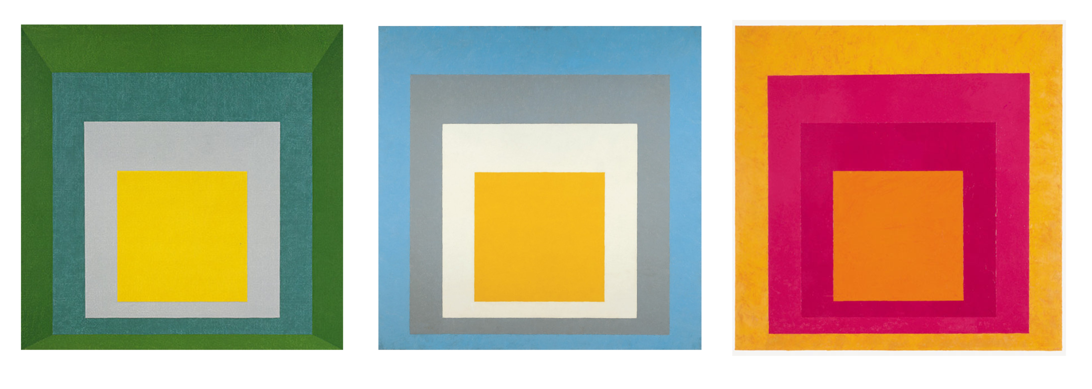
- Should include one complimentary colour along with three analogous colours.

EVALUATION
/5 – craftsmanship (cutting, pasting, presentation)
/5 – Colour Use (demonstrates understanding of colour theory.

