**Ceramics & Sculpture 12**

Point Grey Secondary School - Room 309

Teacher: Ms. Heather Dodge

Email: [hdodge@vsb.bc.ca](mailto:hdodge@vsb.bc.ca)

Ceramics and Sculpture 12 is a senior studio arts course in 3D art. The course focuses on creating, viewing, and reflecting on artworks in personal and cultural contexts. The emphasis of the course is on developing a greater appreciation and understanding of the materials and processes that go into the creation of 3D art.

**Projects**

Students will complete a variety of assignments in glass, ceramics, plaster, stone, wood, found objects, and natural objects. Approximately half of the course is ceramics, including hand building, wheel throwing, and working with slab. Students will also learn basic studio essentials such as managing and reconstituting clay, glazing techniques, and, where possible, raku firing. Students may visit galleries and other art exhibits throughout the year, studying and applying viewing and critiquing skills. Students will be required to talk about their own work, and the work of other artists. Senior students are expected to develop more complexity in their ideas, and demonstrate a greater level of skill.

***Note: Projects for this class are new every year.

**Required Materials**

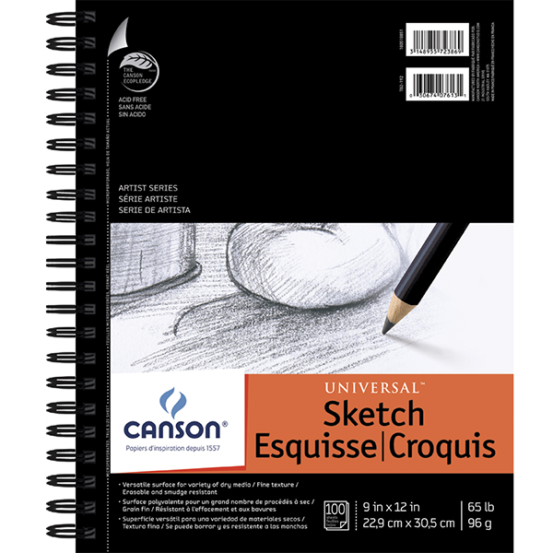Students are ***required*** to use a sketchbook in class. Sketchbooks should be approximately 9X12” with a quality binding or coil. They are available at any art or office supply store. The example on the left is available at Opus Art Supplies for about $10, but any similar sketchbook will work. A partially used sketchbook is fine.

At times students may be asked to bring found and recycled objects for their projects.

**C/S 12 MATERIALS SUPPLEMENT FEE: $30 Due: Sept. 13, 2019**

**Expectations and Evaluation**

Attendance and studio practice are crucial because it is difficult to make up missed classes. Punctuality and absence notes are required. Students may be asked to make up studio time and attend events outside of school hours. When in the art studio, students are expected to be mentally and physically prepared and on task, and keep phones out of sight. There is very little take-home work in these courses, so it is expected that students will use studio time carefully and conscientiously.

Projects and assignments must be submitted by their due dates, and each will be evaluated holistically with emphasis on skill development.

|  |  |
| --- | --- |
|  | **Percentage of Term Mark** |
| Studio work ethic and participation | 20% |
| Assignments | 80% |