Assignment #1: Botanical Drawing (Weeds…)

For this assignment you will research and draw a botanical study in graphite. You must choose a “weed” from our neighbourhood. I can help you identify which weed it is. The drawing will be presented in a formal style on a white background, including a name and description of the plant.
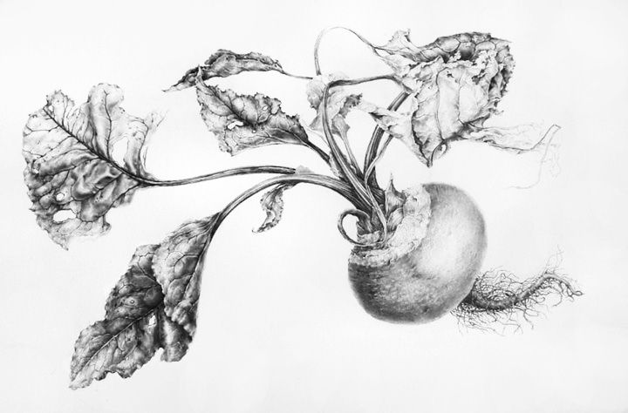

How to complete this assignment:
Part 1:
- Choose a weed. Look outside, along the Arbutus Greenway, in your back yard, along fences, and near areas that are not gardened.
- Keep in mind that a few plants in BC are poisonous or can cause burns, but it’s unlikely that you’ll find them in Vancouver. Please be thoughtful about what you collect, and if you’re not sure, don’t touch it!
- Collect the plant, including the roots if you can get them out. Wrap the roots in a bag with wet paper towel and bring the weed to our next class.

Part 2:
- In class, you will make a botanical study of the plant.
- This includes drawing the whole plant as you see it, so you will need to observe it very carefully.
- Take lots of photos!
- Work on your drawing skills: accurate representation and shading.
- Go slowly and work from light to dark.
- Make sure you leave room on the page for a title and description.
- Make a few thumbnail sketches of your composition in your sketchbook.
- Make sure you leave room on the page for a title and description.

Your final product should look like a botanical study, except it will be of a common “weed.” Viewers should learn something new by looking at your work.

Minimally Meeting xpectations  (C – Range) | Meeting Expectations (B-Range) | Exceeding Expectations (A-Range)
Technical Skill:
- A good range of value from very dark to very light.
- A strong likeness of the plant studied.
- Drawing is arranged in an interesting and satisfying manner on the page.
Concept:
- A local “weed” is used
- Title and description neat and add to the image.
- Information is new or interesting.

Core Competencies:

Acquiring and presenting information
Students communicate by receiving and presenting information. They inquire into topics of interest and topics related to their studies. They acquire information from a variety of sources, including people, print materials, and media; this may involve listening, viewing, or reading, and requires understanding of how to interpret information. They present information for many purposes and audiences, and their presentations often feature media and technology.

