Assignment #3: Personalized Paint Palettes

This year you’ll be painting on a regular basis, and you will need to have a palette. So, this project will allow you to design and make your own!

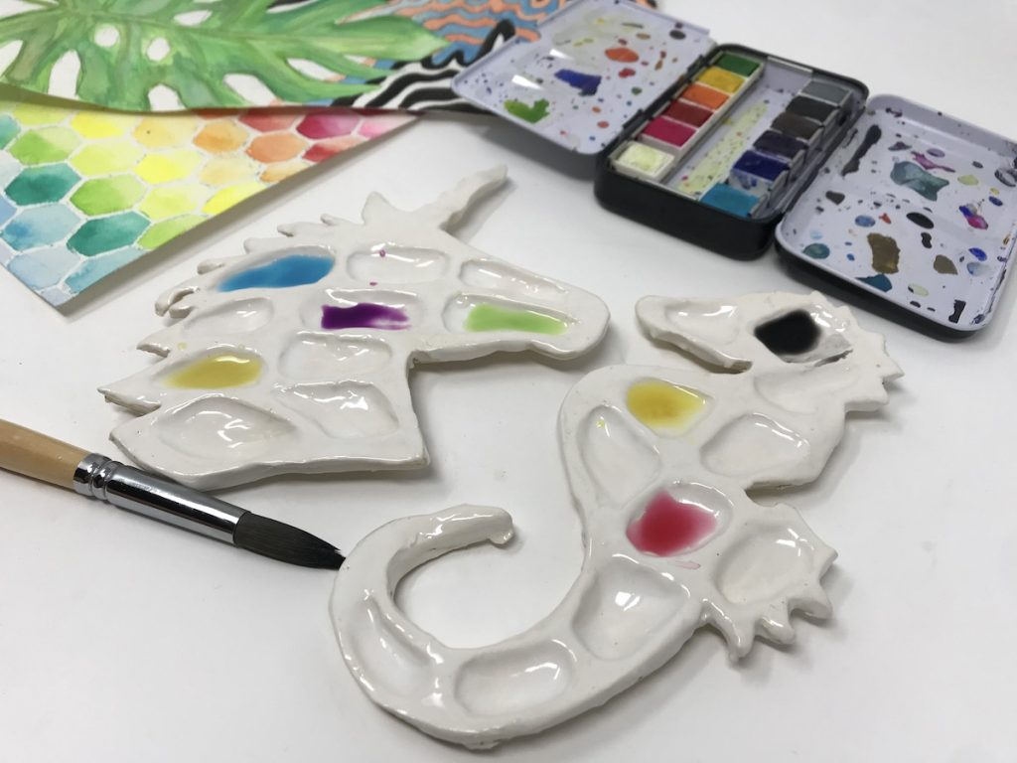
Steps:
- Choose the outline of something that appeals to you. To avoid breakage, it is wise to minimize small pointy bits like the unicorn horn in the picture above.
- Draw your outline on a piece of stiff paper – make sure it’s 20 - 30cm wide. (The clay will shrink by 8-10% when it is fired.) Cut it out: this is your template.
- Make slab that is about 1cm thick. Carefully cut around the template as demonstrated.
- First draw using a pin tool, then carve out using a loop tool, so that you have about 10-12 wells in the palette, and one larger area for mixing colours.
- Smooth and finish all edges.
- Once the clay is starting to harden a little, turn the palette over and attach a “foot” as demonstrated. Carve your name on the bottom.
- Give your project one last smoothing-over and allow to dry.
- Once it is bisque-fired, apply white underglaze and a clear overglaze.
- Use your palette with pride!

Evaluation:

Approaching Expectations  (C-Range) | Meeting Expectations  (B-Range) | Exceeding Expectations  (A-Range)
Design:
- You have chosen and created a recognizable silhouette.
- Your template was carefully made.
- You cut your clay accurately.

Construction:
- You made uniform slab.
- You cut 12 wells in your slab – deep enough to hold paint, but not so deep that they went through the clay.
- You included a larger paint mixing area.
- You neatly attached a clean foot.
- You allowed your clay to stiffen up so that it did not warp.
- You allowed your clay to dry slowly so that it did not crack.

Finishing:
- You applied the underglazes evenly in 2-3 coats.
- Clear glaze was applied evenly in 2 thin coats.
- You cleaned the glaze off the bottom of the foot so that it would not stick to the kiln shelves.

