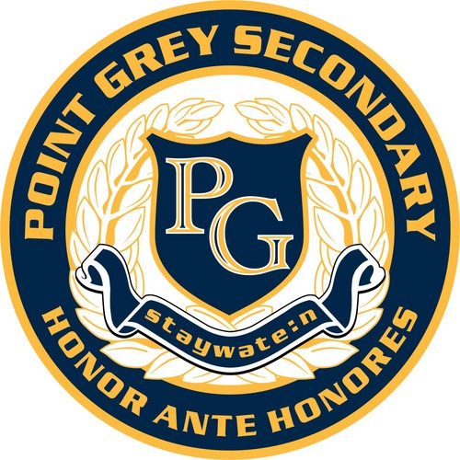
Art 10
Point Grey Secondary School - Room 309
Teacher: Ms. Heather Dodge
Email: hdodge@vsb.bc.ca
PG Art Website: https://pointgreydesign.weebly.com/

Art 10 is a general studio arts course designed for students who enjoy art and are interested in the subject. The course focuses on creating, viewing, and reflecting on artworks in personal and cultural contexts.

Projects

Students will complete a variety of assignments in drawing, painting, printmaking, ceramics, and sculpture. The emphasis is on skill development and personal expression. Students will keep a sketchbook of images and plans for projects.

Required Materials

This year, students are required to use a sketchbook in class. Sketchbooks should be approximately 9X12” with a quality binding or coil. They are available at any art or office supply store. Appropriate sketchbooks can be purchased in class for $5-$10.

Students may use all other art room supplies for their projects. Some students may wish to purchase their own kit of:
- a set of graphite pencils and an eraser
- a small set of watercolour paints, a set of markers, or a set of coloured pencils
- black fineliner

ART MATERIALS SUPPLEMENT FEE: $25 Due by Sept. 12th, 2019

Evaluation

Attendance and class participation are important in Art 10. Students are expected to arrive on time for classes and events, and provide absence notes in the case of missed time. Students may be asked to make up absences during tutorial time, lunch, and after school. When in the art studio, students are expected to be mentally and physically prepared and on task. Phones are to be put away during class. Projects and assignments must be submitted by their due dates, and each will be evaluated holistically according to set criteria, with emphasis on skill development.

 | Percentage of Term Mark
Studio work ethic and participation | 20%
Assignments | 80%

