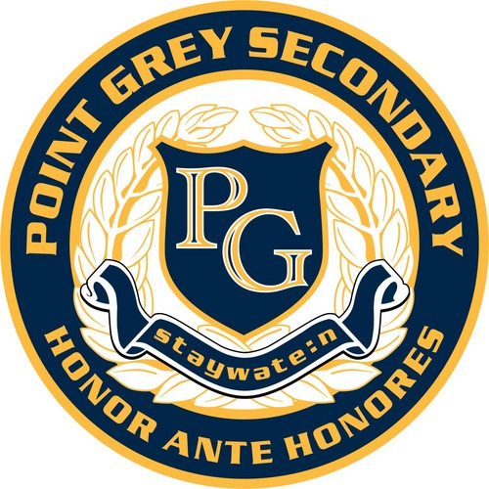
Annual Production 11 /12
Point Grey Secondary School - Room 214
Teacher: Ms. Heather Dodge
Email: hdodge@vsb.bc.ca
Organization: Basecamp 3

Welcome to our 2019-2020 Yearbook class! In this off-timetable course we will be responsible for the production of Point Grey’s Annual. Students will adopt certain roles and responsibilities necessary for the production of the annual including roles in editing, photography, copy and design. Students will receive lessons in all aspects of yearbook production and gain expertise in these areas through hands-on work experience.

The yearbook class will meet regularly every Monday and Wednesday after school from 3:15-4:45, but actual class hours may vary depending on school events and deadlines. Students will be responsible for approximately 60 hrs per term, to be recorded by the teacher advisor. Students may be expected to attend various school functions and events in order to report on them for the annual.

Topics of instruction will include:
- Photography and use of DSLR cameras
- Copy writing and editing
- Layout and design
- Photoshop and InDesign

Expectations:
- Students will come to class prepared and on time.
- Students will inform teacher of any absences and will make up that time.
- Students are encouraged to bring all ideas forth to the editors or advisor
- Students will be responsible for completing all assignments given by advisor or editor.

Course Objectives:
Students will learn and apply:
- basic design and layout knowledge
- basic photography skills, including adjustments for optimal printing
- a solid foundation in Adobe Photoshop and InDesign
- excellent teamwork and communication skills

Grading and Assessment:
Evaluation is carried out on an ongoing basis through teacher’s observation, student participation in yearbook activities, and project marks. Reliability, active participation and a cooperative and responsible attitude as well as skill development will be monitored and evaluated.

 | Percentage of Term Mark
Work ethic and participation; reliability and responsibility; participation in photo shoots and polls. | 20%
Assignments, including layouts and photography. | 80%

There are no fees for this course.

