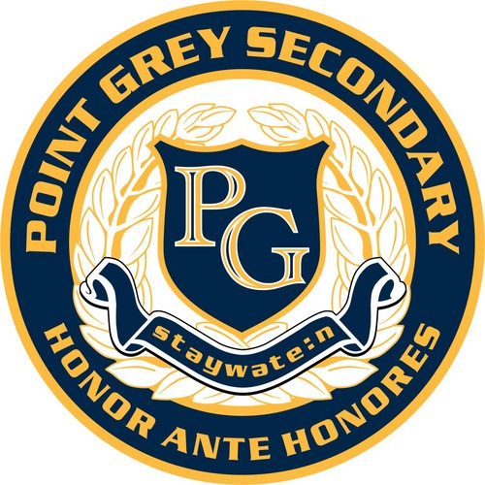**Art and Careers 11**

Point Grey Secondary School - Room 309

Teacher: Ms. Heather Dodge

Email: [hdodge@vsb.bc.ca](mailto:hdodge@vsb.bc.ca)

PG Art Website: https://pointgreydesign.weebly.com/

Art and Careers 11 is a senior studio arts course designed for students considering post-secondary studies in visual arts fields. The course is made up of three components: art creation and the development of a portfolio, research into post-secondary programs, and art viewing and critique.

**Art Creation and Portfolio Development**

Most art schools require a portfolio of a student’s work submitted by February of the student’s grade 12 year. Projects in the course will focus on the development of a strong and varied portfolio to showcase each student’s skills and interests. Part of portfolio development includes learning independent studio practice skills in anticipation of the rigours of art school.

**Research into Post-Secondary Programs in the Visual Arts**

Students will research local, national, and international art programs. They will research types of programs available, admission requirements, portfolio requirements, and funding that might be available to them. We will visit local art schools whenever possible, and schools will come to the school to give presentations.

**Art Viewing and Critique**

Students will visit galleries and other art exhibits throughout the year, studying and applying viewing and critiquing skills. Students will be required to talk and write about their own work, and the work of other artists.

**Required Materials**

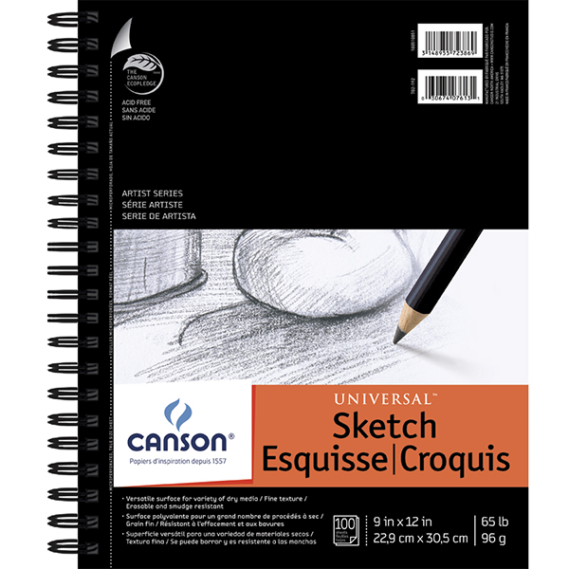

Students are ***required*** to use a sketchbook in class. Sketchbooks should be approximately 9X12” with a quality binding or coil. They are available at any art or office supply store. The example on the left is available at Opus Art Supplies for about $10, but any similar sketchbook will work. Art Careers 11 students do not need to buy a new sketchbook for class, but can continue in their current sketchbook.

Students may use art room supplies for all of their projects. Senior students will benefit from having their own kit of supplies they like, such as:

* a set of graphite pencils
* a small set of watercolour paints and a small selection of brushes
* a set of markers
* a set of coloured pencils
* black fineliners
* an X-acto knife and scissors,
* a set of paintbrushes for acrylics
* pencil sharpener, tortillons, erasers, etc.

**ART MATERIALS SUPPLEMENT FEE: $35 Due by Sept. 13th, 2019**

**Evaluation**

Attendance and work ethic are extremely important in Art and Careers 11. Students are expected to arrive on time for classes and events, and provide absence notes in the case of missed time. Students may be asked to make up missed studio time and attend events outside of school time. When in the art studio, students are expected to be mentally and physically prepared and on task, and keep phones put away.

Students will be expected to work on projects outside of regular class time. They are invited to use the studios during spare blocks, tutorial sessions, lunch time, and after school.

Students are expected to uphold a high level of ethics when using other artists’ work for inspiration. Students will be expected to develop their own skills in image development, research, and visual design. All students should have access to a camera – a phone camera is fine.

Projects and assignments must be submitted by their due dates, and each will be evaluated holistically with emphasis on skill development.

Sketchbooks and process work are foundational in most artists’ practice. Students will be expected to work regularly in their sketchbooks to take notes, try new ideas, think visually, and work on their skill development. Students may, if they wish, add a digital/photo element to their sketchbooks.

|  |  |
| --- | --- |
|  | **Percentage of Mark** |
| Studio work ethic and participation | 20% |
| Assignments and Portfolio Evaluation | 60% |
| Sketchbook | 20% |

**Tentative Course Schedule:**

|  |  |
| --- | --- |
|  | Projects/Events |
| September | Basics of Drawing Unit; Personal visit to VAG (Giacometti) |
| October | Drypoint etching (Annual calendar) Mural Festival Walk; visits from UAL, SOVA, VAG |
| November | Painting; East Van Culture Crawl (Nov. 16-19) |
| December | Tour of ECAID and Gallery visits; Cindy Sherman Tour |
| January |  |
| February | Granville Gallery Walk |
| March | Grad shows (Langara, ECAID, Kwantlen, AI, ?) New York Trip |
| April |  |
| May | Independent Project Due |
| June | Final Interviews |

**Term One Assignments:**

1. Art School Project
2. In and Out of Water Drawing
3. Ink and Coloured Pencil Drawing
4. Independent Concentration Project Assignments
5. Juxtaposition Painting
6. Gallery Responses Assignments
7. Sketchbook work